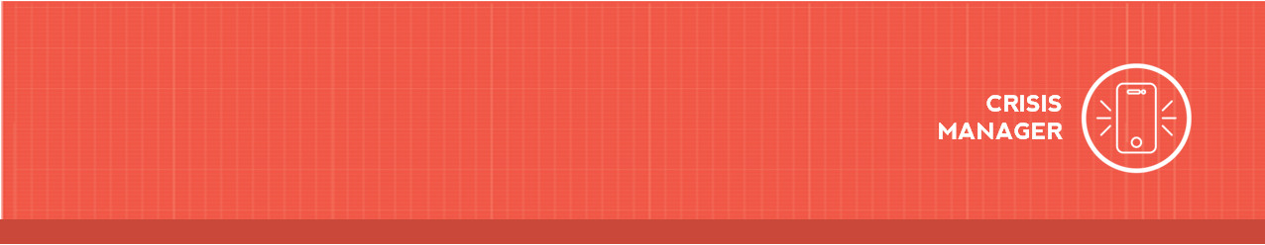

Downloading CrisisManager: Authorized Users

Downloading CrisisManager to your Smartphone
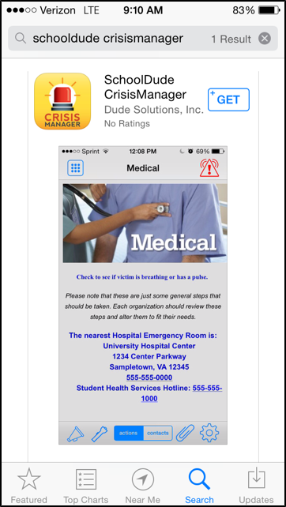
- Access the app store on your smartphone.
- Search for SchoolDude CrisisManager.
- Install the app to your device.
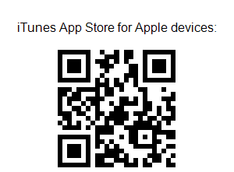
- Or if you have a QR code reader on your smartphone, scan the codes below to locate the app in the store and then install it.

Accessing your Plan

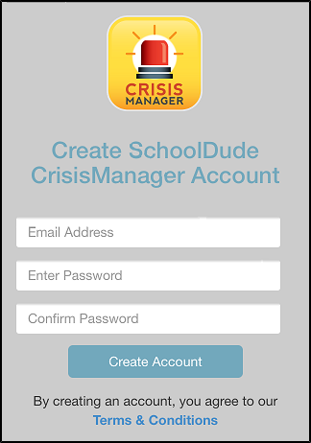
The Administrators that have set up your CrisisManager account have identified you as an Authorized User, meaning you have access to certain plans that cannot be downloaded by other users. To log in as an Authorized User you will first need to create an account in the mobile app.

- Open your CrisisManager app from your smartphone.
- Tap Create Account.
- Enter your Cranbrook Email Address and Password.
*Note: The password you set must meet the following requirements:
Between 8 and 40 characters in length.
Have a least one Uppercase character. Have a least one Lowercase character. Have a least one Numeric character.
Have at least one Other character.
- Tap Create Account when finished.

Downloading CrisisManager: Authorized Users 2

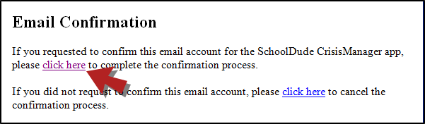
- Once your account has been created you will be sent an email confirmation. Click on the link provided in the email to complete the confirmation process.

- After you have completed the confirmation process, you will need to log back into the app. Go back to your CrisisManager app on your smartphone and tap Back.
- Enter your Cranbrook Email Address and Password and tap Login.
- That will bring you to the Verified Email Addresses page and you will see your email address listed.
- Tap Back in the upper left hand corner, this takes you to the Settings screen.
- Click on < in the upper left hand corner of the Settings screen to return to the home page.
- A Confirm Plan Download pop-up screen will appear giving you the option to download the authorized user plan to which you have been given access.
- Click Yes to download it.
- Once the plan has downloaded, it will appear on your CrisisManager home page. Tap on the plan name to open it.
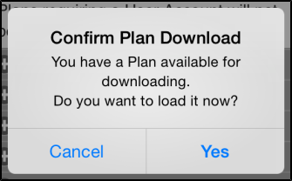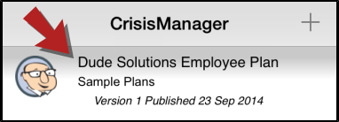

Updating the Plan

If the Administrator updates a plan that you have downloaded, you will be notified by a badge on the CrisisManager app icon.
- Tap the CrisisManager icon to open the app.
- Tap on the plan with the indicator badge to download the new version.

