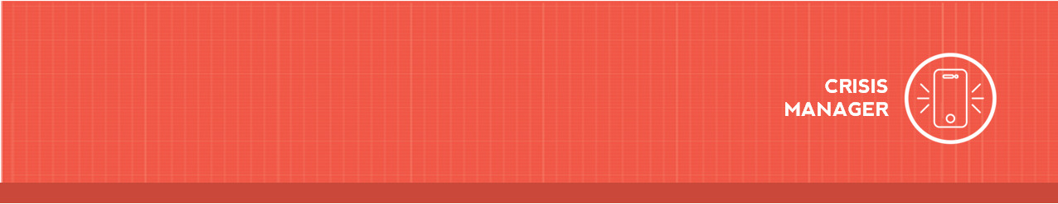

Downloading CrisisManager: Listed Plan

Downloading CrisisManager to your Smartphone
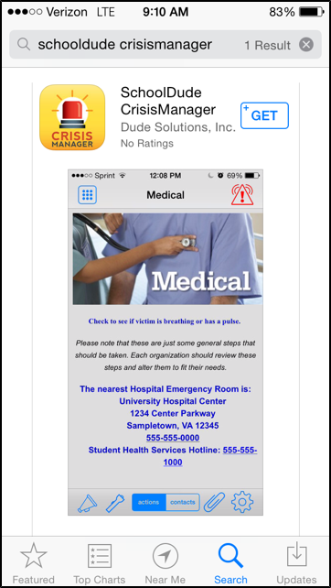
- Access the app store on your smartphone.
- Search for SchoolDude CrisisManager.
- Install the app to your device.
- Or if you have a QR code reader on your smartphone, scan the codes below to locate the app in the store and then install it.

Accessing your Plan

- Tap on the CrisisManager app to open it and tap Continue without logging in.
- Tap on + Client Plans, find Cranbrook Educational Community in the list, and tap on it.
- Tap on Cranbrook Educational Community, General Plan.
- The plan will then download and appear on your CrisisManager home page.
- Tap on the plan to view it.

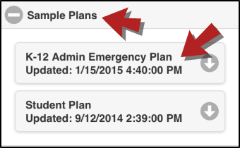

Downloading CrisisManager: Listed Plan 2

Updating the Plan
If the Administrator updates a plan that you have downloaded, you will be notified by a badge on the CrisisManager app icon.
- Tap the CrisisManager icon to open the app.
- Tap on the plan with the indicator badge to download the new version.

